C – Verificación de Condiciones de Bloqueo
Intento 1
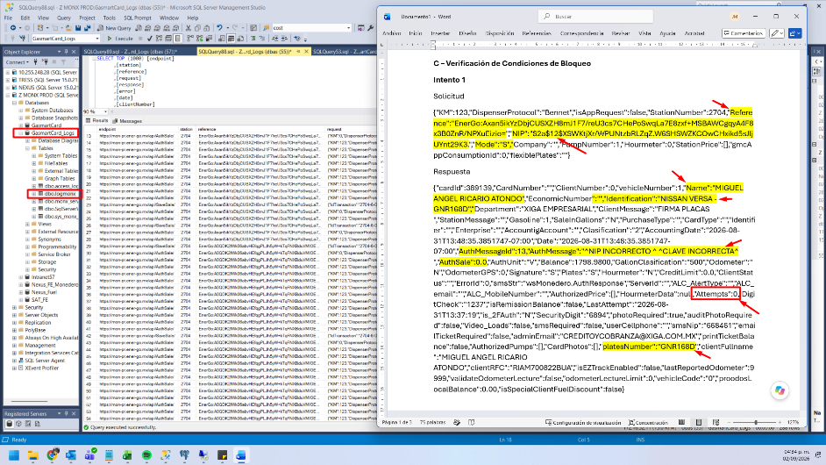
Solicitud
{"KM":123,"DispenserProtocol":"Bennet","isAppRequest":false,"StationNumber":2704,"Reference":"EnerGo:Axan5ikYzDbjCUSXZH8mJ1F7/reU3cs7CHePoSwqLa7E8zxf+MSBAWCgqyA4F8x3B0ZnR/NPXuEizio=","NIP":"$2a$12$XSWKtjXr/WPUNtzbRLZqZ.W6SHSWZKCOwCHxikd5sJljUYnt29K3.","Mode":"S","Company":"","PumpNumber":1,"Hourmeter":0,"StationPrice":[],"gmcAppConsumptionId":0,"flexiblePlates":""}
Respuesta
{"cardId":389139,"CardNumber":"","ClientNumber":0,"vehicleNumber":1,"Name":"MIGUEL ANGEL RICARIO ATONDO","EconomicNumber":"","Identification":"NISSAN VERSA -GNR168D","Department":"XIGA EMPRESARIAL","ClientMessage":"FIRMA PLACAS ","StationMessage":"","Gasoline":1,"SaleInGallons":"N","PurchaseType":"","CardType":"","Identifier":"","Enterprise":"","AccountigAccount":"","Clasification":"2","AccountingDate":"2026-08-31T13:48:35.3851747-07:00","Date":"2026-08-31T13:48:35.3851747-07:00","AuthMessageId":13,"AuthMessage":"^NIP INCORRECTO ^ ^CLAVE INCORRECTA^ ","AuthSale":0.0,"AuthUnit":"V","Balance":1798.9800,"GallonClasification":"500","Odometer":"N","OdometerGPS":0,"Signature":"S","Plates":"S","Hourmeter":"N","CreditLimit":0.0,"ClientStatus":"","ErrorId":0,"smsStr":"wsMonedero.AuthResponse","ServerId":"","ALC_AlertType":"","ALC_email":"","ALC_MobileNumber":"","AuthorizedPrice":[],"HourmeterData":null,"Attempts":0,"DigitCheck":"1237","isRemissionBalance":false,"LastAttempt":"2026-08-31T13:37:19","is_2FAuth":"N","SecurityDigit":"6894","photoRequired":true,"auditPhotoRequired":false,"Video_Loads":false,"smsRequired":false,"userCellphone":"","smsNip":"668461","emailTicketRequired":false,"adminEmail":"CREDITOYCOBRANZA@XIGA.COM.MX","printTicketBalance":false,"AuthorizedPumps":[],"CardPhotos":[],"platesNumber":"GNR168D","clientFullname":"MIGUEL ANGEL RICARIO ATONDO","clientRFC":"RIAM700822BUA","isEZTrackEnabled":false,"lastReportedOdometer":9999,"validateOdometerLecture":false,"odometerLectureLimit":0,"vehicleCode":"0","proodosLocalBalance":0.00,"isSpecialClientFuelDiscount":false}
Intento 2
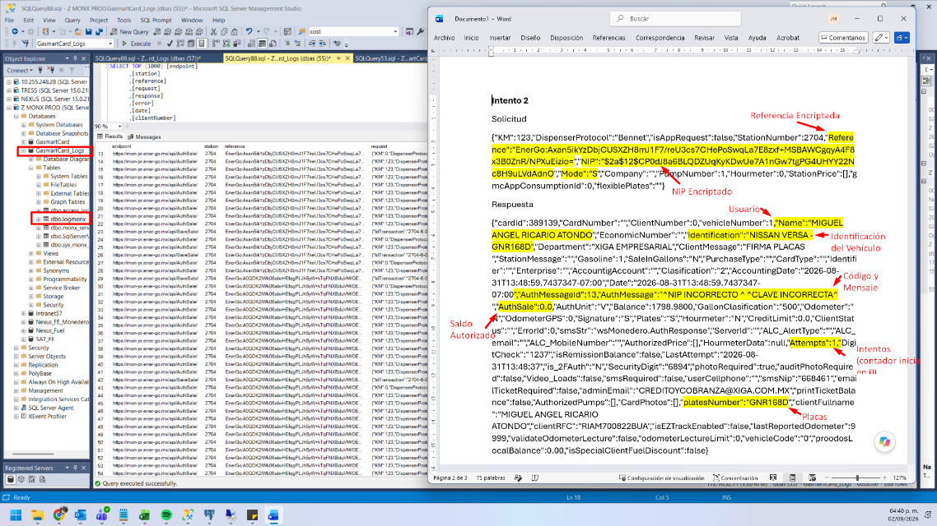
Solicitud
{"KM":123,"DispenserProtocol":"Bennet","isAppRequest":false,"StationNumber":2704,"Reference":"EnerGo:Axan5ikYzDbjCUSXZH8mJ1F7/reU3cs7CHePoSwqLa7E8zxf+MSBAWCgqyA4F8x3B0ZnR/NPXuEizio=","NIP":"$2a$12$CP0dJ8a6BLQDZUqKyKDwUe7A1nGw7tgPG4UHYY22Nc8H9uLVdAdnO","Mode":"S","Company":"","PumpNumber":1,"Hourmeter":0,"StationPrice":[],"gmcAppConsumptionId":0,"flexiblePlates":""}
Respuesta
{"cardId":389139,"CardNumber":"","ClientNumber":0,"vehicleNumber":1,"Name":"MIGUEL ANGEL RICARIO ATONDO","EconomicNumber":"","Identification":"NISSAN VERSA -GNR168D","Department":"XIGA EMPRESARIAL","ClientMessage":"FIRMA PLACAS ","StationMessage":"","Gasoline":1,"SaleInGallons":"N","PurchaseType":"","CardType":"","Identifier":"","Enterprise":"","AccountigAccount":"","Clasification":"2","AccountingDate":"2026-08-31T13:48:59.7437347-07:00","Date":"2026-08-31T13:48:59.7437347-07:00","AuthMessageId":13,"AuthMessage":"^NIP INCORRECTO ^ ^CLAVE INCORRECTA^ ","AuthSale":0.0,"AuthUnit":"V","Balance":1798.9800,"GallonClasification":"500","Odometer":"N","OdometerGPS":0,"Signature":"S","Plates":"S","Hourmeter":"N","CreditLimit":0.0,"ClientStatus":"","ErrorId":0,"smsStr":"wsMonedero.AuthResponse","ServerId":"","ALC_AlertType":"","ALC_email":"","ALC_MobileNumber":"","AuthorizedPrice":[],"HourmeterData":null,"Attempts":1,"DigitCheck":"1237","isRemissionBalance":false,"LastAttempt":"2026-08-31T13:48:37","is_2FAuth":"N","SecurityDigit":"6894","photoRequired":true,"auditPhotoRequired":false,"Video_Loads":false,"smsRequired":false,"userCellphone":"","smsNip":"668461","emailTicketRequired":false,"adminEmail":"CREDITOYCOBRANZA@XIGA.COM.MX","printTicketBalance":false,"AuthorizedPumps":[],"CardPhotos":[],"platesNumber":"GNR168D","clientFullname":"MIGUEL ANGEL RICARIO ATONDO","clientRFC":"RIAM700822BUA","isEZTrackEnabled":false,"lastReportedOdometer":9999,"validateOdometerLecture":false,"odometerLectureLimit":0,"vehicleCode":"0","proodosLocalBalance":0.00,"isSpecialClientFuelDiscount":false}
Intento 3
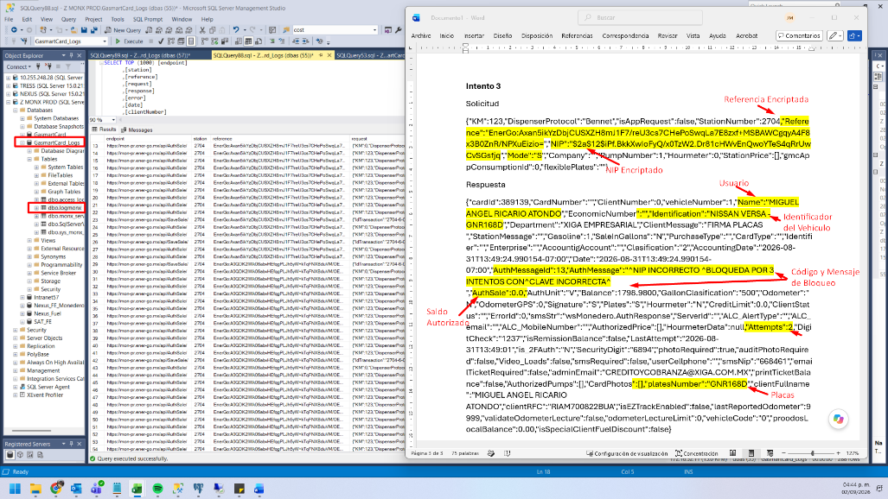
Solicitud
{"KM":123,"DispenserProtocol":"Bennet","isAppRequest":false,"StationNumber":2704,"Reference":"EnerGo:Axan5ikYzDbjCUSXZH8mJ1F7/reU3cs7CHePoSwqLa7E8zxf+MSBAWCgqyA4F8x3B0ZnR/NPXuEizio=","NIP":"$2a$12$iPf.BkkXwIoFyQ/x0TzW2.Dr81cHWvEnQwoYTeS4qRrUwCvSGsfjq","Mode":"S","Company":"","PumpNumber":1,"Hourmeter":0,"StationPrice":[],"gmcAppConsumptionId":0,"flexiblePlates":""}
Respuesta
{"cardId":389139,"CardNumber":"","ClientNumber":0,"vehicleNumber":1,"Name":"MIGUEL ANGEL RICARIO ATONDO","EconomicNumber":"","Identification":"NISSAN VERSA -GNR168D","Department":"XIGA EMPRESARIAL","ClientMessage":"FIRMA PLACAS ","StationMessage":"","Gasoline":1,"SaleInGallons":"N","PurchaseType":"","CardType":"","Identifier":"","Enterprise":"","AccountigAccount":"","Clasification":"2","AccountingDate":"2026-08-31T13:49:24.990154-07:00","Date":"2026-08-31T13:49:24.990154-07:00","AuthMessageId":13,"AuthMessage":"^NIP INCORRECTO ^BLOQUEDA POR 3 INTENTOS CON^CLAVE INCORRECTA^ ","AuthSale":0.0,"AuthUnit":"V","Balance":1798.9800,"GallonClasification":"500","Odometer":"N","OdometerGPS":0,"Signature":"S","Plates":"S","Hourmeter":"N","CreditLimit":0.0,"ClientStatus":"","ErrorId":0,"smsStr":"wsMonedero.AuthResponse","ServerId":"","ALC_AlertType":"","ALC_email":"","ALC_MobileNumber":"","AuthorizedPrice":[],"HourmeterData":null,"Attempts":2,"DigitCheck":"1237","isRemissionBalance":false,"LastAttempt":"2026-08-31T13:49:01","is_2FAuth":"N","SecurityDigit":"6894","photoRequired":true,"auditPhotoRequired":false,"Video_Loads":false,"smsRequired":false,"userCellphone":"","smsNip":"668461","emailTicketRequired":false,"adminEmail":"CREDITOYCOBRANZA@XIGA.COM.MX","printTicketBalance":false,"AuthorizedPumps":[],"CardPhotos":[],"platesNumber":"GNR168D","clientFullname":"MIGUEL ANGEL RICARIO ATONDO","clientRFC":"RIAM700822BUA","isEZTrackEnabled":false,"lastReportedOdometer":9999,"validateOdometerLecture":false,"odometerLectureLimit":0,"vehicleCode":"0","proodosLocalBalance":0.00,"isSpecialClientFuelDiscount":false}

